**Report: Online Theater Booking Process Analysis and Improvement**

**Title: Online Theater Booking Process Analysis and Improvement**

**Presented by:** Group – 7: Nikhil, Maisha, Raghav, Rahul, Somya  
**Date:** May 28 2024

**Introduction**

This document provides an analysis and improvement plan for online theater booking. The objective is to evaluate the current process, identify inefficiencies, and propose enhancements to streamline the booking experience for customers.

The report covers a detailed description of the current booking process, a visual representation through a process flowchart, and an in-depth analysis identifying key bottlenecks. Based on the study, several improvement suggestions are made to optimize the process. The document concludes by comparing the original and improved process models and provides recommendations for implementation.

**Detailed Process Description**

The online theater booking process involves several key steps:

1. **Customer Initiation:** The customer decides to book a theater ticket online and visits the booking website or app.
2. **Browsing and Selection:** The customer logs in or creates an account, browses available movies or shows, selects a movie or show, and chooses the preferred date and time.
3. **Seat Selection:** The customer views the seating layout, selects the desired seats, and reviews them.
4. **Payment Process:** The customer proceeds to checkout, enters payment details, reviews the order summary, and confirms the booking by making the payment.
5. **Booking Confirmation:** The system processes the payment, and the booking confirmation details are sent to the customer via email or app notification.

**Process Flowchart**

To better understand the sequence of actions and decision points in the online theater booking process, a flowchart representation is provided.

**Original Process Flowchart Steps:**

1. **Start:** Customer decides to book a theater ticket online.
2. **Visit Booking Website/App:** Login/Create an account, browse available movies/shows, select movie/show, date, and time.
3. **Seat Selection:** View the seating layout, select desired seats, and review selected seats.
4. **Payment Process:** Proceed to checkout, enter/select payment details, review the order summary, and confirm booking by making payment.
5. **Booking Confirmation:** Payment processed, confirmation details sent via email/app notification.
6. **End**

**Process Analysis and Improvement Suggestions**

**Analysis of Bottlenecks and Inefficiencies:**

1. **Account Creation/Login:** New users often find it time-consuming to create an account, and there can be issues with password recovery.
2. **Seat Selection:** There are delays in loading the seating layout, especially during peak times, and customers may find it difficult to visualize available seats.
3. **Payment Process:** There can be delays or failures with the payment gateway, and a complex checkout process can lead to cart abandonment.

**Suggested Improvements:**

1. **Streamlined Account Creation/Login:**
   * Implement social media login options for quick access, such as allowing users to log in with Google or Facebook accounts.
   * Improve the password recovery process by offering instant recovery options like SMS or email verification codes.
2. **Enhanced Seat Selection:**
   * Optimize the seating layout for faster loading times by using efficient data retrieval methods and reducing the amount of graphical data loaded simultaneously.
   * Implement 3D visualizations of seating arrangements to help customers better understand the layout and make more informed decisions.
3. **Simplified Payment Process:**
   * Offer multiple payment options, including digital wallets like PayPal, Apple Pay, and Google Wallet, to cater to a wider range of customer preferences.
   * Implement one-click checkout for returning customers by securely storing their payment and booking information, reducing the steps required to complete a transaction.
   * Ensure robust and secure payment gateways by partnering with reliable payment service providers and conducting regular security audits to protect customer data.

**Improved Process Flowchart**

The improved flowchart representation incorporates the suggested enhancements.

**Improved Flowchart Steps:**

1. **Start:** Customer decides to book a theater ticket online.
2. **Visit Booking Website/App:**
   * **Login/Create Account:** Implement social media login options.
   * **Browse Movies/Shows:** Browse available movies/shows.
   * **Select Movie/Show:** Select a movie/show, date, and time.
3. **Seat Selection:**
   * **View Seating Layout:** Optimize layout for faster loading.
   * **3D Visualization:** Provide 3D visualizations of seating arrangements.
   * **Select Desired Seats:** Select desired seats and review them.
4. **Payment Process:**
   * **Proceed to Checkout:** Proceed to checkout.
   * **Enter Payment Details:** Enter/select payment details.
   * **One-Click Checkout:** Offer one-click checkout for returning customers.
   * **Review Order Summary:** Review order summary.
   * **Confirm Booking:** Confirm booking and make payment.
5. **Booking Confirmation:**
   * **Payment Processed:** Payment processed securely.
   * **Confirmation Sent:** Confirmation details sent via email/app notification.
6. 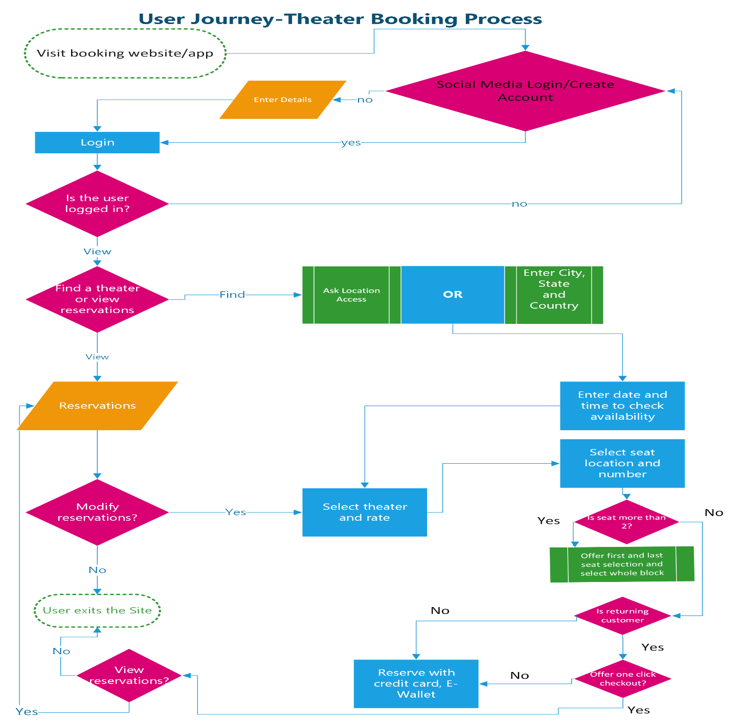**End**

**Summary and Conclusion**

To summarize our findings and suggested improvements:

* We detailed the online theater booking process, from customer initiation to booking confirmation.
* We created a flowchart to visualize the steps and decision points in the process.
* Our analysis identified key inefficiencies in account creation, seat selection, and the payment process.
* We suggested improvements such as streamlined account creation with social media log-in, enhanced seat selection with 3D visualization, and a simplified payment process with multiple payment options and one-click checkout.

**Expected Benefits:**

* Enhanced efficiency in booking tickets due to faster account access and seat selection.
* Improved customer satisfaction from a smoother booking experience and more payment options.
* Overall better customer experience and operational performance for the theater.

**Conclusion:**

Implementing these improvements can significantly enhance the theater booking experience, making it more user-friendly and efficient. Thank you for your attention. We are now open to any questions you may have.